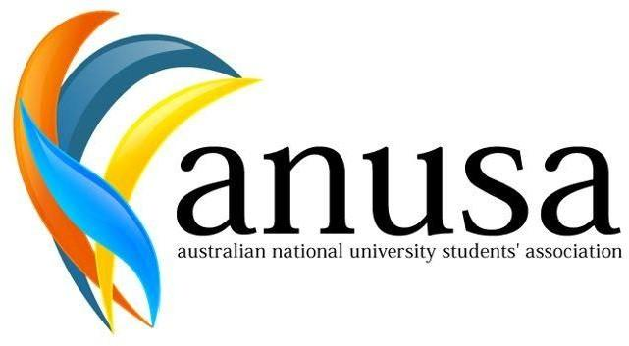

AUSTRALIAN NATIONAL UNIVERSITY STUDENTS’ ASSOCIATION The Australian National University

Canberra ACT 0200
T: +61 02 6125 2444
E: sa.clubsofficer@anu.edu.au
http://anusa.com.au

Notice of Meeting:
Clubs Council Meeting (CCM) 1 2022

Date: Monday, 7 March 2022

Time: 12:00pm – 2:00pm

Location: Zoom

Can I come?

All ANU students can attend but only Clubs delegates and members of the Clubs Council Executive can vote.

If you wish to submit a motion, please email it to the Clubs Officer by COB 4th Marchas sa.clubsofficer@anu.edu.au.

If you have any questions, please don’t hesitate to contact sa.clubsofficer@anu.edu.au.

Phoenix O’Neill
Clubs Officer
28 February 2022

